**REPORT**

Due to COVID-19, formal education was süsende in schools in many countries around the world, including Turkey. The effects of the pandemic crisis on education were also directly felt in our country. The education system was already in a crisis before the pandemic. It can be seen that this negative picture in education has worsened after the pandemic. In short, this crisis has deepened rapidly with the pandemic process. The use of technology in education has naturally increased during the pandemic process. As technologies increasingly affect the lives of societies, the demand for education has increased and education has gained importance as never before. With the increasing importance of education and technology, a "digital" division has emerged between those who can access this information and technology and those who cannot. EBA TV, which provides the most common access opportunity in the distance education process, was mainly used. In distance education with television, there is no teacher-student interaction, it is not possible to monitor the student's reactions and provide feedback, and the learning of students whose self-learning skills are not sufficiently developed has been seriously insufficient. Even when we consider these, 60% of the students in Turkey did not even enter EBA in this process.Access to technological tools by students in Turkey One of the most important determinants of how efficient the distance learning process, which emerged as a result of the COVID-19 epidemic, can be for students is the technological opportunities that students have at home.Students who do not have access to technological tools such as computers, internet and smart phones at home are more disadvantaged in this process.

The Organization for Economic Co-operation and Development (OECD) defined the digital divide that I mentioned earlier as "the difference between those who can access information technologies and those who cannot." And published a report called 'Education in the Covid-19 Pandemic 2020'. Turkey ranked 64th from 77 countries in the list of students.

tablo içeren bir resim

Açıklama otomatik olarak oluşturuldu

tablo içeren bir resim

Açıklama otomatik olarak oluşturuldu

In this picture, the rankings of countries for accessing the internet according to OECD. Turkey ranked 70th in the list of "students with internet access".

While the situations are like this in OECD, I wanted to find the values that measure the internet access rates in our country, the technological devices owned and the internet network band used.

The results of TUIK's Household Information Technologies Usage Survey can be used to have an idea about access to technological tools throughout the country.

**I created these charts with the "DataWrapper" tool.**

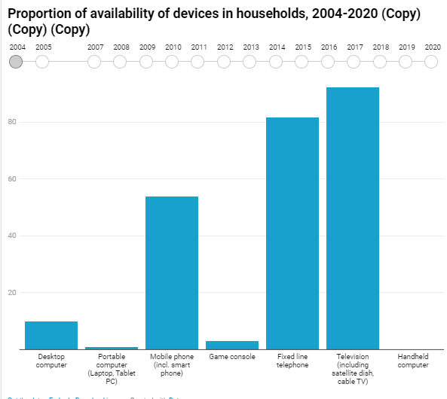

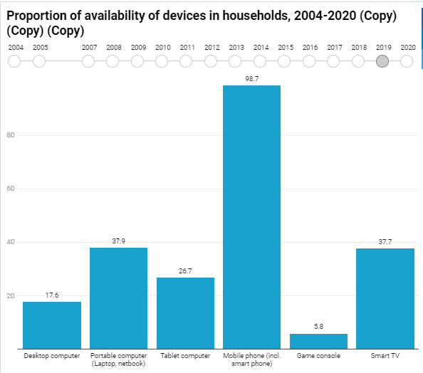

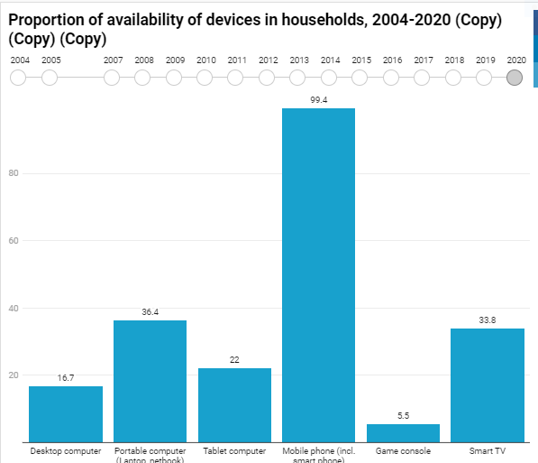

First of all, I would like to explain the availability of devices in households. Since 2004, the use of vehicles has definitely increased with the development of technology.According to TUIK data, households in Turkey the rate of having internet access is 90.7%

* 16.7% of households with desktop computers,
* 36.4% of households with portable computers,
* 22% of households with tablets and
* 99.4% of households with mobile phones.

From 2019 to 2020, the use of PCs and tablets decreased, and the use of mobile phones increased. The proportion of households with a desktop computer, portable computer or tablet is also very low; Even if a household has internet access, it may not have the technological tools necessary to use distance education content efficiently. In other words, if household internet access is provided only through mobile phones, both the internet capacity and the features of the phones used may not be sufficient for an effective distance learning process.

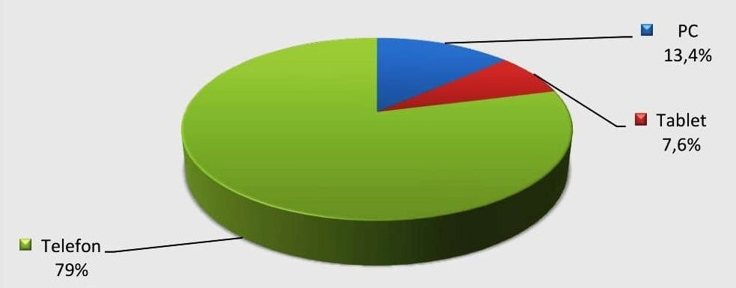

In summary, According to these data, nearly every Internet connection in 1 in 10 households not available and approximately 30% of students cannot access devices such as computers and tablets. Most of the time, they can take classes from a small-screen mobile phone.

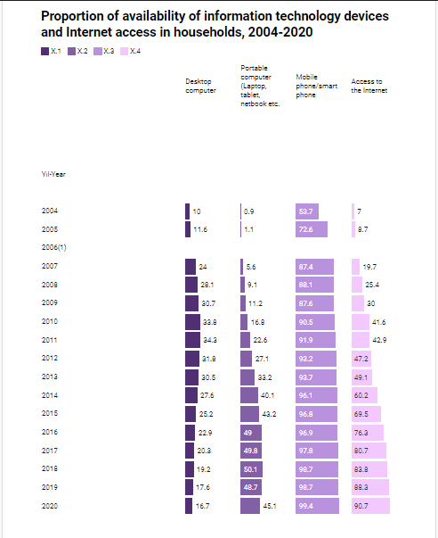

Secondly, we saw that one out of 10 people could not access the internet and I wanted to investigate these rates in more detail.

Which region has more access to the Internet? And which region is more disadvantaged? Moreover, what are the internet access rates from 2019 to 2020 and the internet connections of those who access it? I tried to answer these questions.

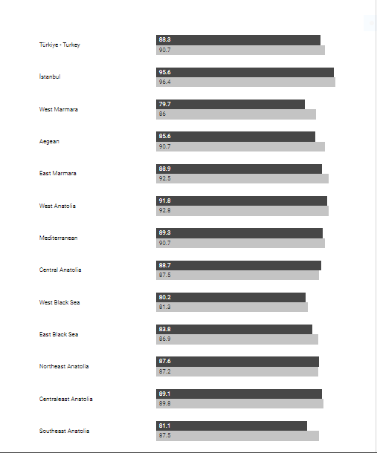

Dark grays represent 2019. Light grays represent 2020.As we can see, internet access is decreasing towards the East region. The rate of access to the internet has increased from 2019 to 2020 due to the distance education that came with Covid, but the rates still show that approximately 1 out of 10 people cannot reach us.

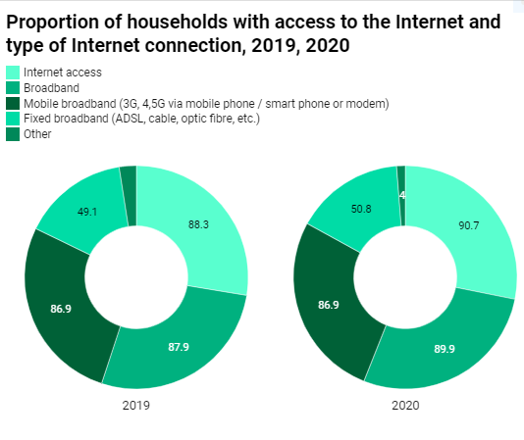

According to TUIK data, 49.1% of households in Turkey use ADSL, cable Internet, fiber etc. with fixed broadband connection and 86.9% with mobile broadband connection. Middle East Anatolia (25.6%), Northeast Anatolia (25.8%) and Southeast Anatolia (27.2%) have fixed broadband regions with the lowest percentage of households

In addition to providing remote access opportunities for universities, it is also important for students to reach remote access. In a study conducted among university students during the pandemic period; It has been determined that only 63% of the students have an internet connection at home, and 66% have a computer or tablet. In other words, one third of the students do not have computers and tablets. 64% of students have distance access education from computers or tablets; 32% of them are using their smartphones; It was found that 23% of them could not participate in distance education.

When the data on students' access to distance education in Turkey are evaluated together with the effectiveness of distance education tools, serious limitations are encountered.

**Finally,**

The target audience in this report and homework is distance education students from primary school to university . How many students can access the internet? How many of them have educational facilitators such as Pc, tablet?

While the internet has become a compulsory need today, we have to keep up with the times, but in these years, there are still too many students who cannot access the internet and do not have a computer in our country. This shows us how great inequality there is in education. My aim is to fully inform about these issues and I interpreted the graphics I created accordingly.